Garfield-Clarendon Model Railroad Club

Layout Control System

4501 N Clarendon Avenue

Chicago, IL 60640

Troubleshooting Guide

Overview

When the system is not working correctly, it is usually related to the communication between the LCS Controllers via the club’s Wi-Fi. The issue is usually one of the following:

1. One or more of the LCS controllers are no longer connected to the Wi-Fi.
2. One or more of the LCS controllers are no longer communicating with the module boards connected to it (the I2C serial bus is down)
3. The club’s Wi-Fi network is malfunctioning.

This guide is broken down into **Symptoms** and **Solutions.**

# Symptom: A control panel has stopped responding. When a button or switch is pressed, nothing happens.

#### Solution 1: Reset the panel’s controller(s).

1. Find the controller(s) connected to the panel. The controller should be either inside the panel or mounted nearby. The controller has a red power LED.
2. Un-plug the power cable from the controller. Wait a few seconds and plug the power back in.
3. Wait for the board to reboot. This can take up to a minute.
4. If the blue “Wi-Fi connected” LED does not turn on, there is an issue with the club’s Wi-Fi network. See Resetting the Wi-Fi.

# Symptom: A control panel has stopped responding. When a button or switch is pressed, LED’s begin flashing but the turnouts do not throw.

#### Solution 1: The controllers running the turnouts have stopped responding. Reset those controllers

1. Find the controller(s) running the turnouts that are controlled from the panel. Currently, these controllers are located under the east end of CA, behind the main CA panel on the lower right corner and under the west end of CA. The controllers have a red power LED.
2. Un-plug the power cable from each controller. Wait a few seconds and plug the power back in.
3. Wait for the board to reboot. This can take up to a minute.
4. If the blue “Wi-Fi connected” LED does not turn on, there is an issue with the club’s Wi-Fi network. See Resetting the Wi-Fi.

# Symptom: The signals coming into CA stopped working.

#### Solution 1: The controller running the signals has stopped responding. Reset that controller.

1. The signals coming into CA are managed by a controller mounted under the layout near the signals. The controller has a red power LED.
2. Un-plug the power cable from the controller. Wait a few seconds and plug the power back in.
3. Wait for the board to reboot. This can take up to a minute.
4. If the blue “Wi-Fi connected” LED does not turn on, there is an issue with the club’s Wi-Fi network. See Resetting the Wi-Fi.

#### Solution 2: The controllers running the turnouts or the controllers monitoring the block detectors has stopped responding. Reset those controllers.

1. Currently, these controllers are located under the east end of CA, behind the main CA panel on the lower right corner and under the west end of CA. The signals coming into CA are managed by a controller mounted under the layout near the signals. The controller monitoring the block detectors in Bridgeport are mounted in the far right panel in Bridgeport. The controllers have a red power LED.
2. Un-plug the power cable from the controller. Wait a few seconds and plug the power back in.
3. Wait for the board to reboot. This can take up to a minute.
4. If the blue “Wi-Fi connected” LED does not turn on, there is an issue with the club’s Wi-Fi network. See Resetting the Wi-Fi.

# Symptom: The crossing switch indicator on the signal mast and/or on the CA panel is not operating properly.

#### Solution 1: The controller running the crossing switch monitor has stopped responding. Reset that controller.

1. The controller is located in Courthouse mounted under the layout on mounted on the same board as the relays controlled by the crossing switch. The controller has a red power LED.
2. Un-plug the power cable from the controller. Wait a few seconds and plug the power back in.
3. Wait for the board to reboot. This can take up to a minute.
4. If the blue “Wi-Fi connected” LED does not turn on, there is an issue with the club’s Wi-Fi network. See Resetting the Wi-Fi.

# Resetting the Wi-Fi

The club’s Wi-Fi system is known as a Mesh Network and has multiple Linksys Velop Wi-Fi units:

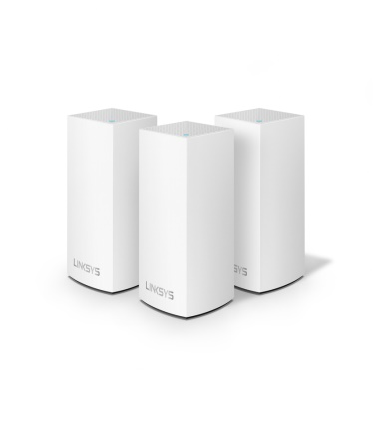

The club currently owns two of these units: one sitting on the large box mounted on the wall behind the overlook and one sitting on the steel bracket next to the center column in the middle of Georgetown. To reset the club’s Wi-Fi, both of these units must be reset.

1. Unplug the unit
2. Wait 30 seconds and plug the unit back in

It takes the Wi-Fi units between 3 – 5 minutes to startup.

*BE SURE TO RESTART BOTH UNITS*.

***Note:*** **Turning the layout off does not turn off the Wi-Fi units. They must be restarted manually.**

# Full Restart

If all else fails, restart the entire system and layout.

1. Restart the Wi-Fi network. See Resetting the Wi-Fi.
2. Wait 3 to 5 minutes to give the Wi-Fi a chance to startup.
3. Turn OFF the switch mounted at the bottom of the center column in Georgetown.
4. Turn the layout OFF.
5. Wait 30 seconds or so
6. Turn the layout back ON.
7. Turn ON the switch mounted at the bottom of the center column in Georgetown.